Unit 1:
1.Write a Java program to demonstrate the concept of classes and objects. Create a class named Student with data members such as student name and student age. Create an object of the class and display the student details using a method.
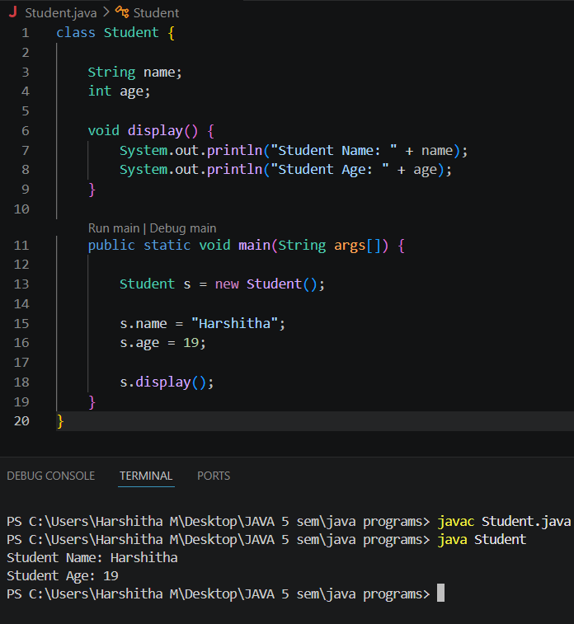

2. Write a Java program to demonstrate the concepts of inheritance and polymorphism. Create a parent class named Animal and a child class named Dog. Use method overriding to achieve runtime polymorphism and display the behaviour of both classes.
